Microsoft 365 Apps (Office)
Official URL: https://services.smsu.edu/TDClient/180/Portal/KB/Article/3033/Microsoft-365-Apps-Office
Category: Knowledge Base > Information Technology Services > Software and Applications > Microsoft 365 Apps (Office)
Tags: microsoft, office, outlook, word, excel, powerpoint, apps
_____________________________________________________

Microsoft 365 Apps – Overview and Installation Instructions
Current students, faculty, and staff receive Microsoft 365 Apps at no cost through MinnState.
Microsoft 365 Apps include:
- Word
- Excel
- PowerPoint
- Outlook
- OneDrive
- OneNote
- Teams
- Forms
- And other Microsoft productivity tools
Eligible users can install Microsoft 365 Apps on up to five personally owned Windows or macOS computers.
Microsoft 365 Apps are also supported on iOS and Android mobile devices.

Instructions to Install Microsoft 365 Apps on Windows or macOS
- Login to your account at www.office.com using your StarID@go.minnstate.edu (students) or starid@minnstate.edu (faculty/staff).
- Click on Apps in the menu located on left side of the page
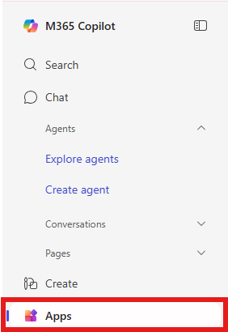
Figure 1: Left sidebar navigation of Microsoft 365 Copilot showing menu options including Search, Chat, Agents, Conversations, Pages, Create, and Apps, with the Apps option highlighted in a red box.
- Click on Install apps on the top right corner
- When the drop down menu appears select Microsoft 365 apps
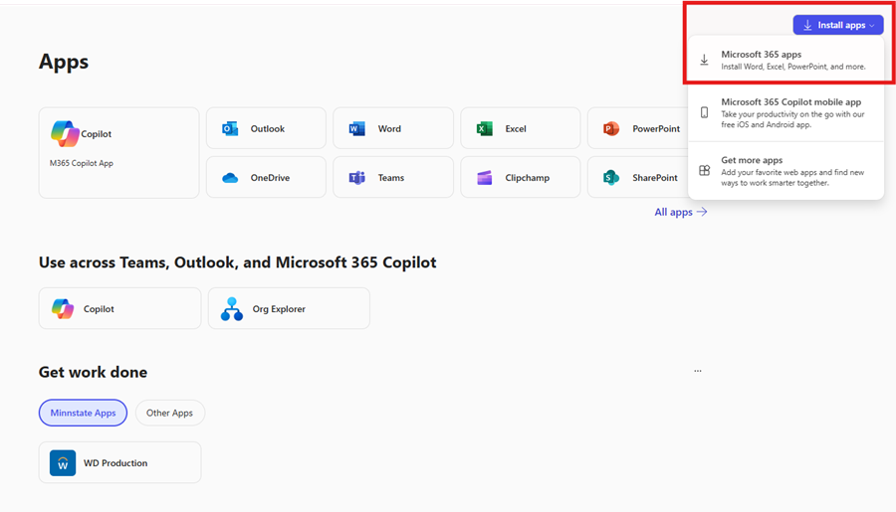
Figure 2: Microsoft 365 Apps page showing a grid of applications such as Copilot, Outlook, Word, Excel, PowerPoint, OneDrive, Teams, Clipchamp, and SharePoint, with the ‘Install apps’ dropdown menu open in the top-right corner.
- Click on Install Office
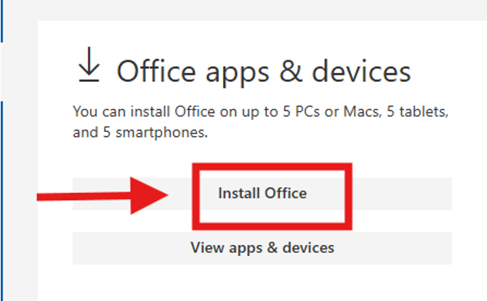
Figure 3: Microsoft Office apps and devices page displaying an ‘Install Office’ button, with a red arrow pointing to the button and a red box highlighting it.
- Follow instructions (depending on your computer specifications and web browser) to download and install Office. After the download is complete, please run the .exe file or downloaded file for MAC if it does not automatically start.
- Once Office 365 is installed you will find the programs among the other programs on your computer.
- ACTIVATION - The first time you start an Office app, choose to log in and use the format StarID@go.minnstate.edu (students) or starid@minnstate.edu (faculty/staff) and your StarID password. This will activate the software and enable full Office functionality and software updates
Accessibility Review & Update Log:
- [ ] Content accuracy verified
- [ ] Color contrast checked
- [x] Image alt-text verified (screenshots auto-captioned)
- [x] Document structure and headings formatted (perfect bold, list bulletpoints and sequences preserved)

